Introduction of JavaScript

JavaScript is the world's most popular programming language.

JavaScript is the programming language of the Web.

JavaScript is easy to learn.

Javascript is a lightweight, cross-platform, and interpreted scripting language. it is well-known for the development webpages,

many non- browser environments also use it.

javascript is used to make webpages interactive (e.g., having complex animations, clickable buttons, popup menus, etc.)

javascript can be used for client side development as well as server side developments

javascript contains a standard library of object like array, date, and math and core set of language element like operator

control structure and statements.

Why Study JavaScript?

JavaScript is one of the **3 languages** all web developers **must** learn:

   1. **HTML** to define the content of web pages

   2. [**CSS**](https://www.w3schools.com/css/default.asp) to specify the layout of web pages

   3. **JavaScript** to program the behavior of web pages

No need of compilers : since JavaScript is an interpreted languages, therefore it does not need any compiler for

compilations.

Used both client and server side : Earlier JavaScript was used to build client side application only, but with the

evolution of its framework namely Node.js and Express.js, it is now widely used for building server side application too.

Helps to build a complete solution : as we saw, js is widey used in both client and server side application, therefore it helps us to build an end to end solution to a given problem

used everywhere : js is so loved b'cz it can be used anywhere. it can be used to develop website, games or mobile apps etc.

huge community support : js has huge community of users and mentors who love this language and take it's legacy forward.

Difference between client side and server side

**Client side**

It supplies object to control a browser and its document object model (DOM). Like if client

side extensions allow an application to place elements on an HTML form and respond to user

event such as mouse click, form input and page navigation. Useful libraries for the client side are

**Angular JS, React JS, Vue JS, and so many others.**

**Server side**

It supplies objects relevant to running JavaScript on a server. Like if the server side extension

allow an application to communicate with a database and provide continuity of information

from one invocation to another of the application or perform file manipulation on a server.

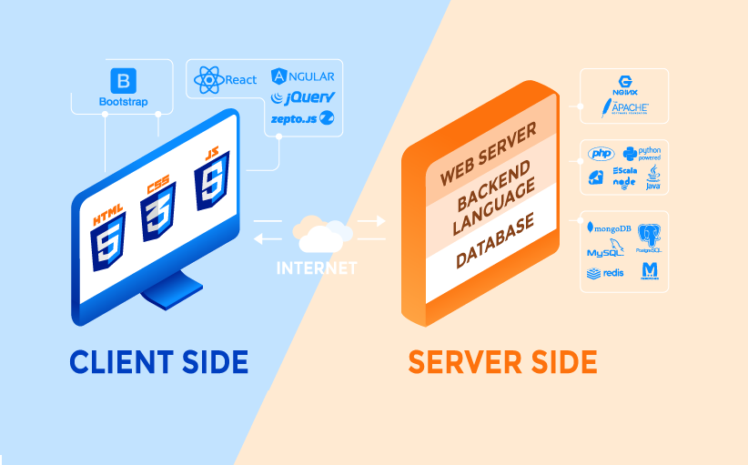**The useful framework which is the most famous these day is node.js.**

**History**

* It was created in 1995 by Brendan Eich while he was an engineer at Netscape. It was originally going to be named LiveScript but was renamed. Unlike most programming languages, the JavaScript language has no concept of input or output.
* It is designed to run as a scripting language in a host environment, and it is up to the host environment to provide mechanism for communicating with outside world. The most common host environment is the browser

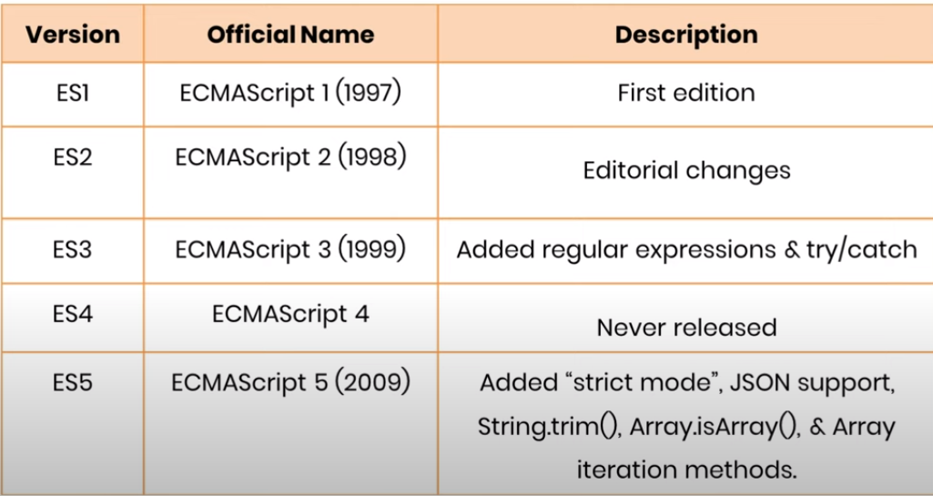

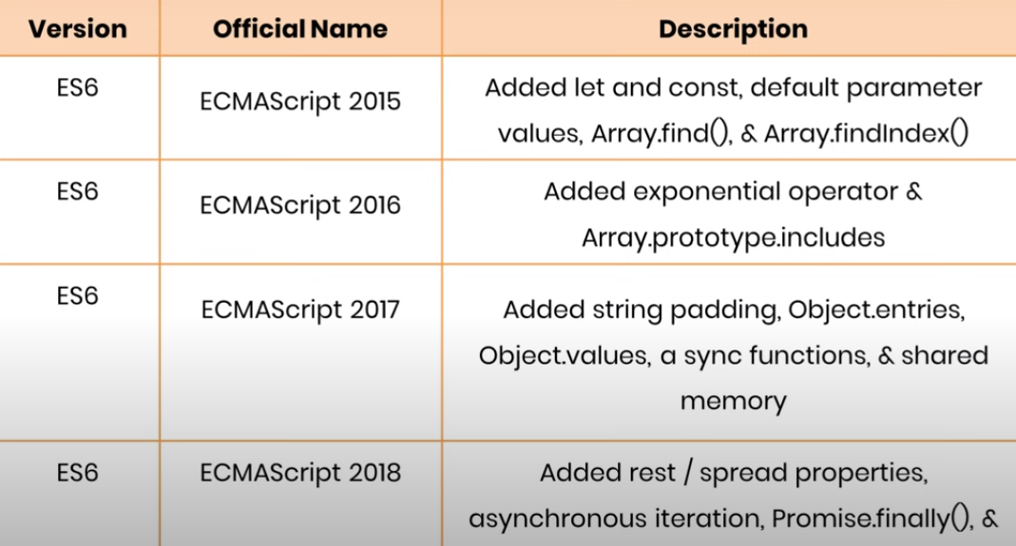

**Features**

**According to a recent survey conducted by stack overflow. JavaScript is the most popular language on earth.**

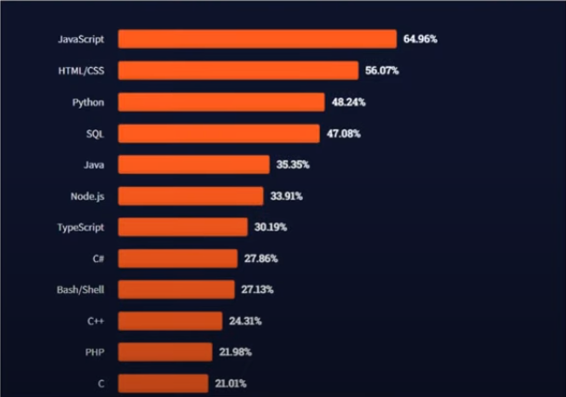

**With advance in browser technology and js having moved into server with node.js and other frameworks, js is capable of so much more. Here are a few things that we can do with JavaScript :**

* **JavaScript was first place for DOM manipulation. Earlier website were mostly static, after JS was created dynamic websites were made.**
* **Function in JS are objects. They have many properties and method just like another object. They can be passed as argument in other functions.**
* **Can handle date and time.**
* **Perform form validation although the forms are created using HTML**
* **No compiler is needed.**